Shell Scripting

Creating or opening a file in vim editor: -



Shebang (Specifying the interpolator) and commenting lines: -

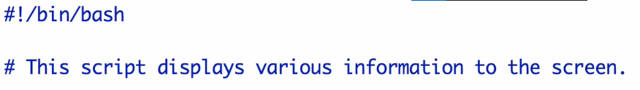

Know permissions: -



File owner/ user permissions

Group members permissions

Everyone else’s permissions

Basic permission distribution: -





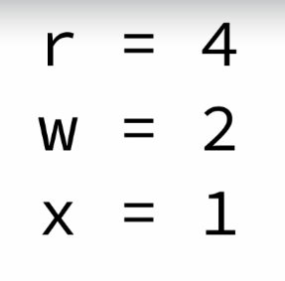

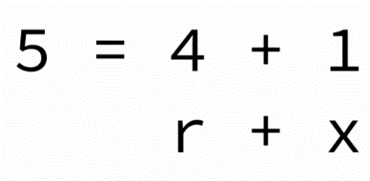

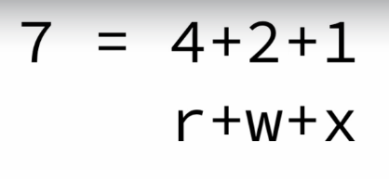

Display something to the screen: -

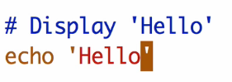

Some points: -

* **.** 🡪 Current Directory
* **..** 🡪 Previous directory
* / 🡪 directory separator
* In Linux file extension doesn’t matter

Renaming a file: -

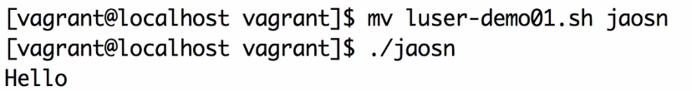

Creating an empty file: -



To know a command is shell builtin or not: -

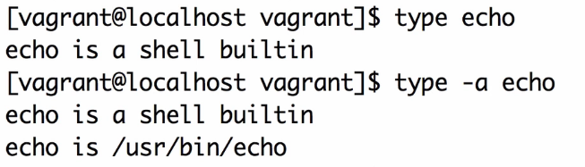

To get help on some shell builtin command: -

* **help command_name**
* It won’t work if the command is not shell builtin, instead use **man** **command_name**
* Type **q** to exit from man

Working with variables: -

* There are no spaces among variable name, = sign and the string
* **Single quotation** restricts the expansion of variables
* If we do echo ‘$WORD’ it will print $WORD
* Previous point is applicable for other commands as well

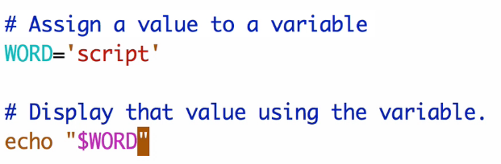

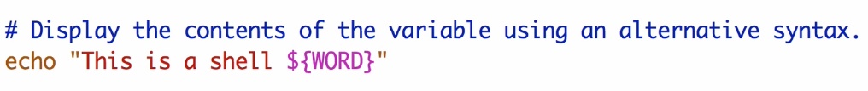

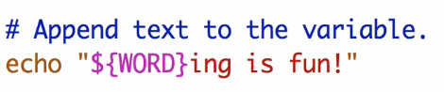

We must use this syntax to append text, if not using **space** after the variable name

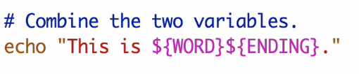

Quick point: -

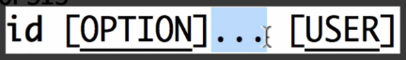

Those dots represent multiple options can be provided

If you want to store the result of a command in a variable: -

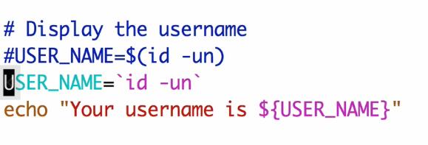

First method is recomended

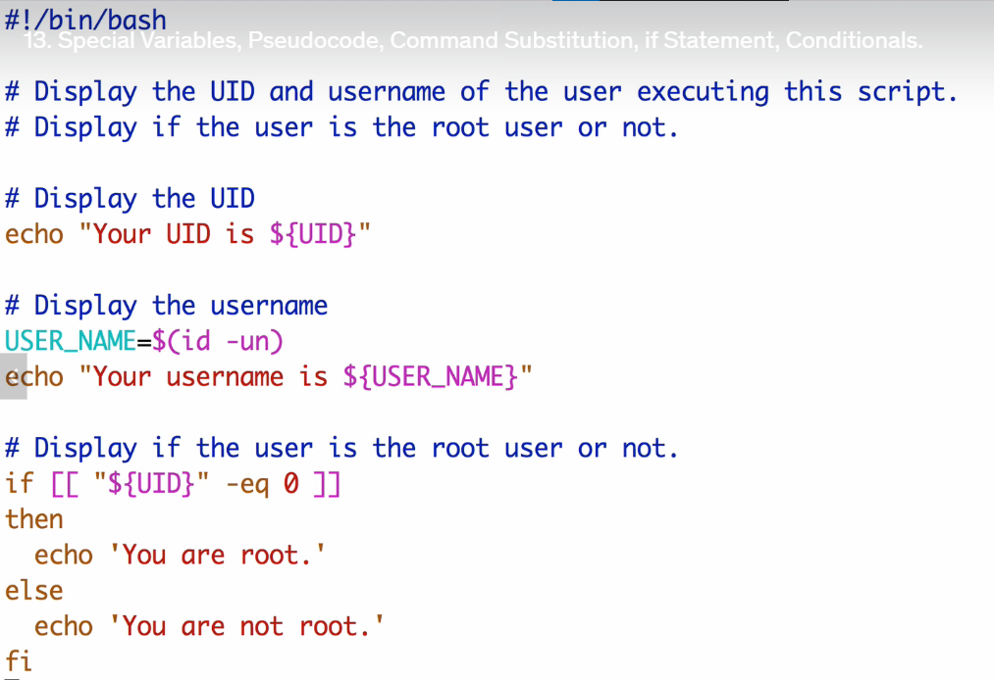

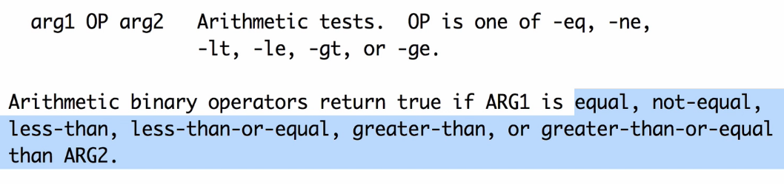

* These don’t work with strings

Exit status: -

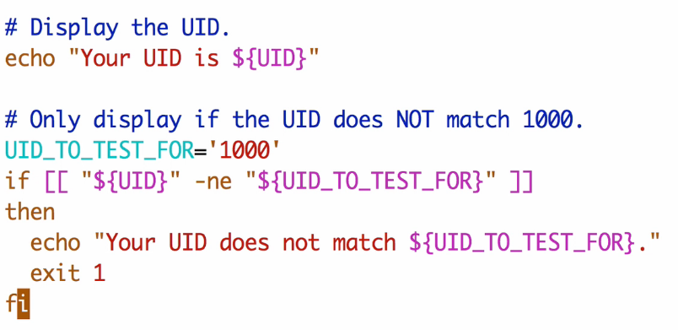

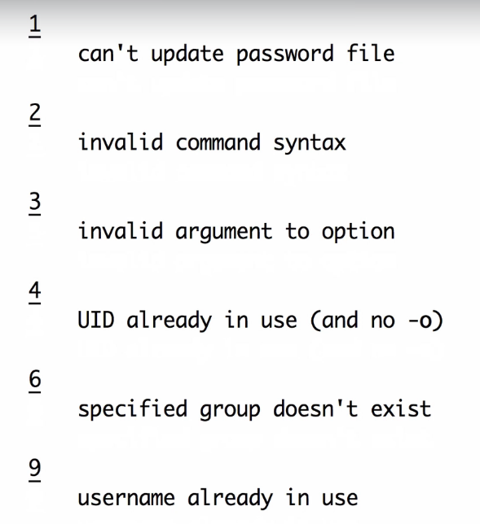

* Exit status 0 🡪 Success
* These numbers are just an example. These could be anything

Checking exit status: -

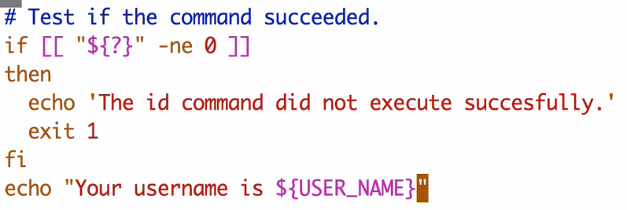

* “${?}” this captures the exit status of the most recently executed command

Test string conditions: -

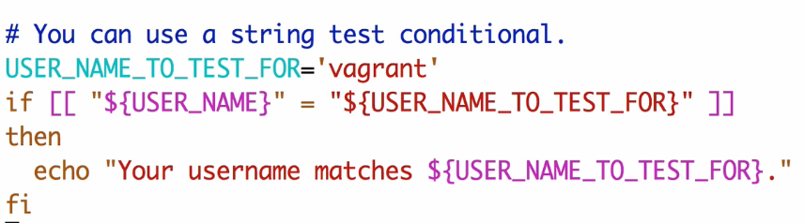

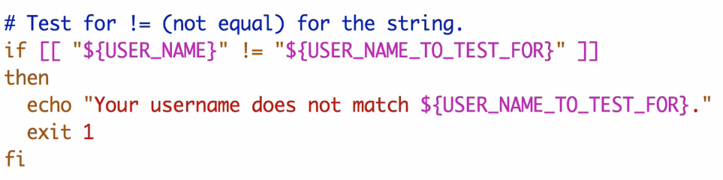

Taking user input: -

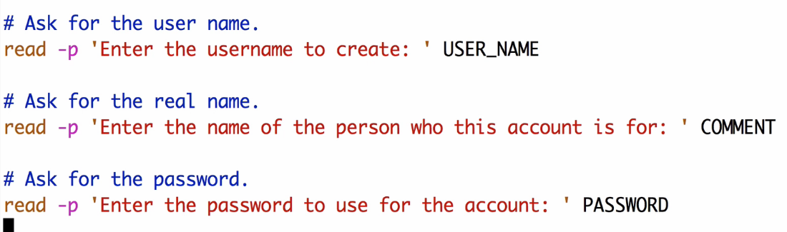

* -p stands for prompt

Output of one command is input for another: -

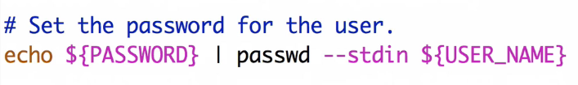

Printing some line from our file: -



Printing some character from our file: -

